BABU BANARSI DAS UNIVERSITY

LUCKNOW

SCHOOL OF COMPUTER APPLICATIONS

BCA(CYBER SECURITY & FORENSICS)

3RD SEMESTER



SUBJECT - IDENTITY ACCESS MANAGEMENT

PROJECT TOPIC – IMAGE STEGANOGRAPHY

SUBMITTED TO SUBMITTED BY

MR. ANAND KUMAR ANUSHKA SAHAY

ROLL NO. – 22

BCACS21

IMAGE STEGANOGRAPHY

**Image Steganography** is a technique used to conceal secret information within digital images in such a way that the existence of the hidden data is not apparent. This method ensures that the image appears unchanged to an observer, while the embedded data can only be extracted by someone who knows the embedding technique or has the necessary decryption key.

Steps to perform image steganography are as follows :-

STEP 1 : Create a folder named as “steganography”

STEP 2 : Download a jpg format image from the browser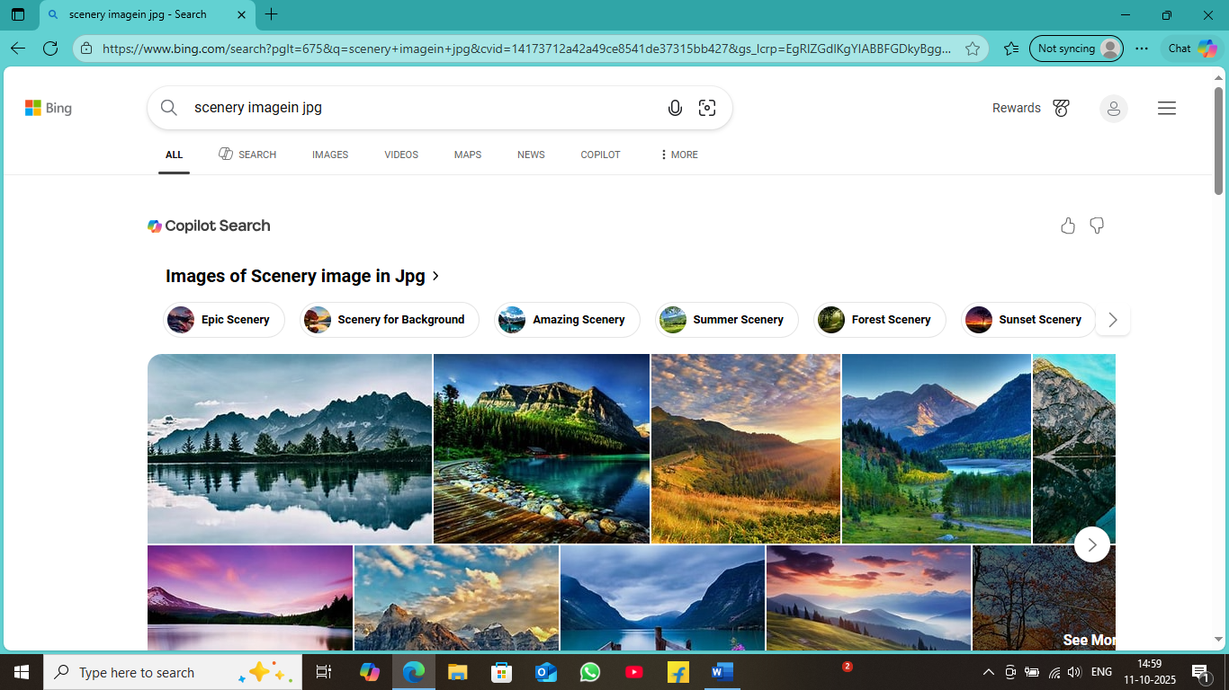

STEP 3 : Save that image inside the folder named as “steganography”. And rename the image to “scenery”

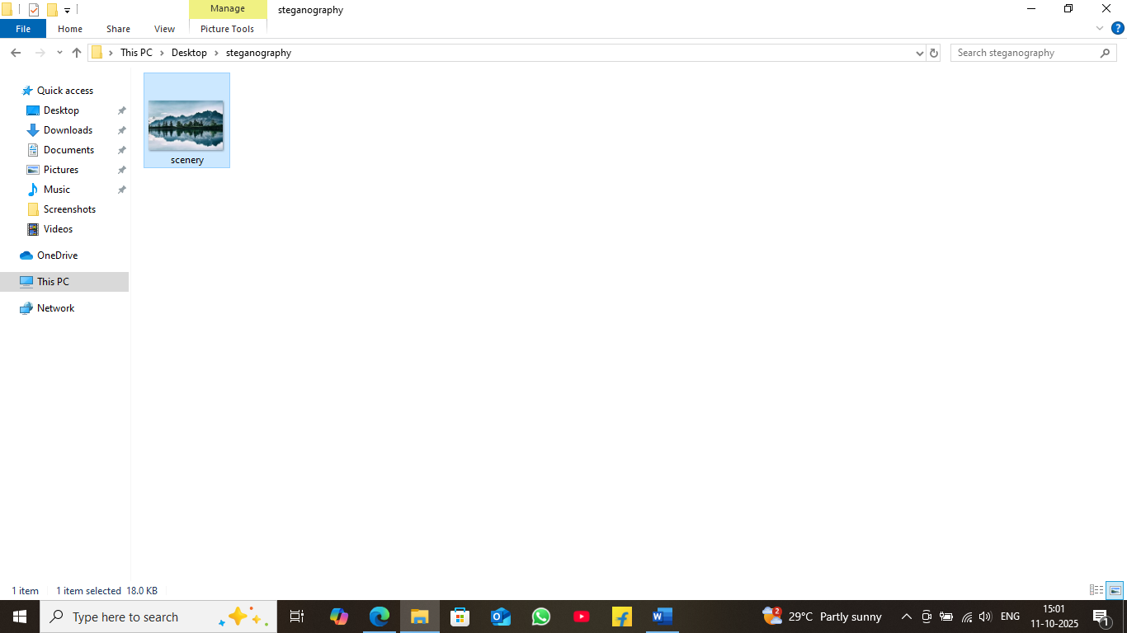

Step 4 : Select and open the folder using “powershell”

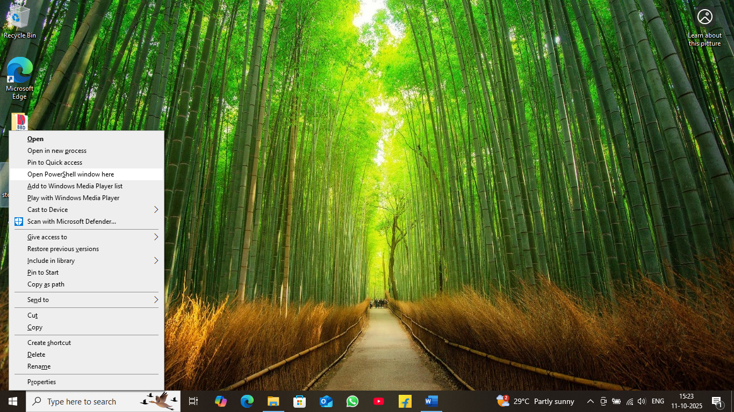

STEP 5: Type “ls” command in powershell to view the content of the folder.

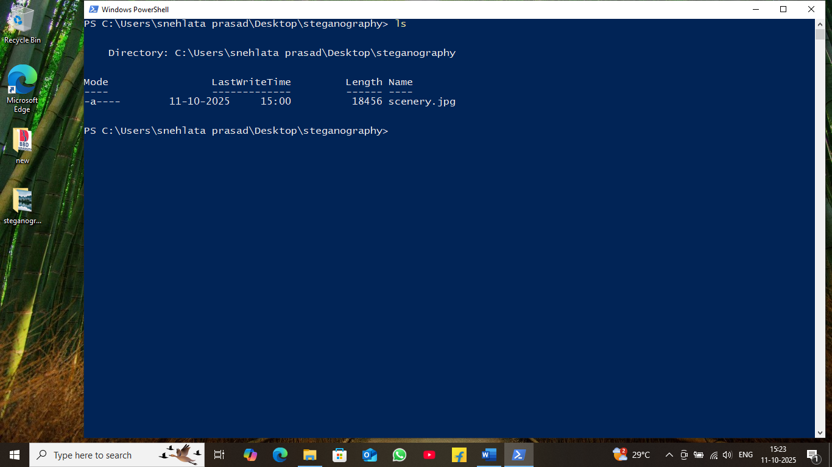

STEP 6 : Type ““echo “montains” >> scenery.jpg ”” in powershell to hide the code “mountains in the image named as “scenery.jpg”

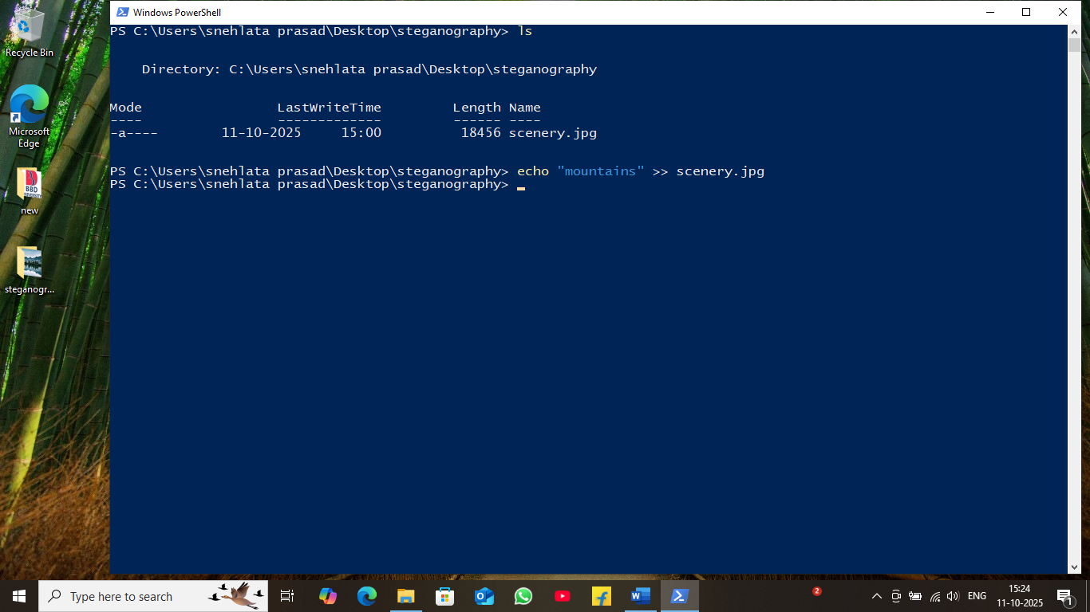

STEP 7 : Now open the image using “notepad”.

STEP 8 : Now we can see the hidden message inside the image.

